St. Robert Short Story & Art Competition

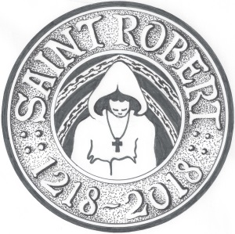

Name of author/artist
Age of author/artist on the 20th July 2018
Parent, guardian or teacher
E-mail of parent, guardian or teacher

Please submit your short story or artwork before mid-night on the 20th July 2018, to competition@strobertofknaresborough.org.uk

[By submitting this short story or artwork you agree to be bound by the final decision of the judges and to have given permission for the story or artwork to be published, if chosen, as part of the celebrations for the 800th anniversary of St. Robert of Knaresborough.]

If you are submitting artwork, please submit this document in addition to your artwork, which should be attached as a .jpg file, to the email address above.

If you are submitting a short story, then please paste your story below before submitting this document to the email address above…

