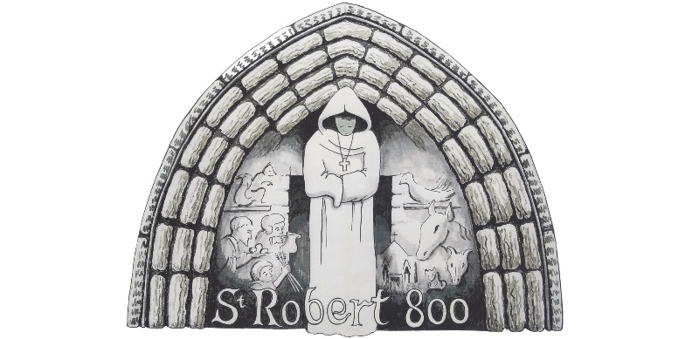
St. Robert of Knaresborough Feast
Special Guest Information

Name of Special Guest:

Address of Special Guest:

Name of Individual/Group Purchasing Ticket:

Why did you choose this person?

Once complete please email the form to info@strobertofknaresborough.org.uk

